July monthly report
โครงการ P2451496 งบยุทธ_CCU68_การต่อยอดและพัฒนาเทคโนโลยี Carbon capture and utilization (CCU) ที่มีความต้องการจากภาคอุตสาหกรรม และขับเคลื่อน National CCUS Alliance ร่วมกับเครือข่ายพันธมิตร
Sothearoth Heng
Under the supervision of
Dr. Pongkarn Chakthranont
ใบสั่งจ้างเลขที่ PO25005060
จ้างเหมาพัฒนางานจ้างพัฒนาการขยายขนาดเซลล์ไฟฟ้าเพื่อการผลิตแก๊สสังเคราะห์จาก CO₂ เชิงเคมีไฟฟ้า
งวดที่ 4: 1 July 2568 – 31 July 2568
……..........................................................
Dr. Pongkarn Chakthranont

- To-do list in July
- 100cm² electrolyzer – CO₂ electrolysis of 0.5Ni-SAC under a pure CO₂ at 100mA/cm²
- Experimental Procedure
Synthesis of NiSAC by pyrolysis method
The synthesis of NiSAC catalyst was followed by our previous work. Initially, nickel phthalocyanine (NiPc), urea, and dicyanamide precursors were stoichiometrically weighed according to mass ratios of x:5:5, wherein urea and dicyanamide were maintained at 5 g each while varying the NiPc content (x = 0.25, 0.5, 1.0, and 2.0 g). Subsequently, the mixture was thoroughly mixed and ground until a homogeneous midnight blue powder was obtained. The fine powder was then transferred into a quartz boat covered with a capsule lid and subjected to polymerization at 800 °C (ramp rate = 10 °C·min⁻¹) in a horizontal tube furnace under an argon atmosphere (flow rate = 200 sccm) for 2 h. The as-prepared xNiSAC catalysts with different NiPc contents were finally obtained and labeled as 0.25NiSAC, 0.5NiSAC, 1.0NiSAC, and 2.0NiSAC.
Fabrication of IrO₂/TiPt felt anode electrode
The IrO₂/TiPt-felt anode electrode was prepared using a thermal deposition method involving multiple sequential steps. Initially, the TiPt felt (Purchased from ...) substrate was ultrasonically cleaned with deionized water and acetone to remove any surface contaminants. The cleaned substrate was subsequently etched in a 6M HCl solution at 90°C for 45 min to enhance surface roughness and adhesion properties. The dip-coating solution was prepared by dissolving 200 mg of IrCl₆·xH₂O in 18 mL of isopropanol (IPA) containing 10% v/v HCl (2 mL of conc. HCl). The etched TiPt felt substrate was then immersed in the dip-coating solution, followed by drying at 100°C for 5 min in an oven and subsequent calcination at 500°C for 10 min in a muffle furnace. After cooling to room temperature, the treated substrate was reweighed to determine mass gain. This dipping-drying-calcination cycle was repeated several times until the desired IrO₂ mass loading (1±0.2 mg/cm²) was achieved.

Preparation of NiSAC cathode electrode via spray coating method
The NiSAC gas-diffusion electrode was fabricated by spray coating onto Sigracet 39BB carbon paper or hydrophilic carbon cloth substrates. Typically, 150 mg of as-prepared NiSAC and 381 μL of XC-2 ionomer were ultrasonically dispersed in 10 mL of isopropanol (IPA) for at least 1 h to form a homogeneous dark colloidal suspension. The ink suspension was subsequently spray-coated onto a 6x6 cm² carbon substrate using an automated, custom-built spraying setup equipped with a syringe pump operating at a flow rate of 0.6 mL min⁻¹ on a hotplate maintained at 110°C, yielding a catalyst mass loading of 1.8 ± 0.1 mg.cm⁻².

Electrochemical measurements in membrane-electrode assembly (MEA) electrolyzer
100cm2 MEA electrolyzer operational set-up
A 100 cm² MEA electrolyzer was used to evaluate the CO2RR performance under modulated operating conditions. The Ni foam or IrO₂-TiPt felt (10.5 x 10.5 cm²), bipolar membrane (BPM, 15.6 x 16.8 cm²), and 0.5Ni-SAC (10.5 x 10.5 cm²) were employed as the anode, membrane, and cathode electrode, respectively. The MEA was assembled with 0.25µm PTFE gasket and tightened at a compression force of 25 Nm. 1.0 L of 0.25 M KOH was recirculated and used throughout the experiment as the anolyte at 100 ml/min. The humidified CO₂ gas stream was introduced into the cathodic inlet with a total CO₂ flow rate of 200 or 500 ml/min. Prior the test, the electrochemical impedance spectroscopy (EIS) and Cyclic voltammetry were measured. Meanwhile, the cathodic outlet was directly injected into an online gas-chromatography for gas products analysis.
Long-term stability of CO₂ electrolysis
A 5 cm² MEA electrolyzer was used to evaluate the CO2RR performance under modulated operating conditions. The Ni foam, bipolar membrane (BPM), and different cathode catalysts were employed as the anode, membrane, and cathode electrode, respectively. 500 ml of 0.25 KOH was recirculated and used throughout the experiment as the anolyte at 8 ml/min. The KOH electrolyte was refreshed regularly. The 0.5M acetic acid-humidified CO₂ gas stream was introduced into the cathodic inlet under total flow rates of 150 or 20 ml/min. Meanwhile, the cathodic outlet was directly injected into an online gas-chromatography for gas products analysis.

- Results
CO₂ electrolysis of 0.5Ni-SAC in a 100cm² MEA electrolyzer under pure CO₂
The CO2RR performance of a large-scale MEA electrolyzer was preliminarily evaluated under pure CO2 at 200 ml/min and 0.25M KOH at 100 ml/min at 10A (100 mA/cm²) with a cell configuration of 0.5NiSAC(1.8 mg/cm²) |BPM| Ni foam. The MEA electrolyzer was assembled with key components including a 0.25 µm PTFE gasket (10.2 × 10.2 cm²) with 4 holes (both anode and cathode), a BPM size of 10.5 × 10.5 cm², and a compression force of 60 in·lbs. Based on the first operation as depicted in Figure 1 (1st operation), the overall system performance was identical to that of the 5 cm² electrolyzer in terms of CO selectivity (FECO > 97%) and cell voltage (~3.6V), except for the instability of the larger electrolyzer. Furthermore, we observed gas/liquid leakage from both sides, liquid droplets in the cathodic flow-field channel, and pressure buildup at the cathode outlet (during the GC injection period) that could potentially cause the instability of the overall system.
In order to address this, we hypothetically considered increasing the compression force from 60 to 120 in·lbs and replacing the 0.25 µm gasket with a 0.3 µm one to ensure the tightness of the cell assembly. As shown in the 2nd operation, the overall cell performance showed identical results in terms of FE(CO) and cell voltage for the first 2 hours and became flooded afterwards. Based on our observations, this second operation demonstrated similar issues to the previous run with gas/liquid leakage and liquid droplets. According to the 2nd operation, we assumed that the leaking region should be located at the interface between the membrane and electrode, which might have resulted from a small BPM size. Therefore, we further enlarged the BPM size to fully cover the cathodic endplate from 10.5 × 10.5 cm² to 15.6 × 16.8 cm². Surprisingly, the gas/liquid leakage was solved with this strategy, except for the formation of liquid droplets at the cathodic flow-field channel and pressure buildup at the cathode outlet. The overall cell performance of this 3rd run was comparable to the previous run with a lifespan of 3 hours before GDE flooding occurred afterwards. It is worth noting that water accumulation (liquid droplets) at the flow-field channel of the cathode side is the main issue that occurs with a parallel flow field design because the pressure drop at the exit is too low to force out the water, causing the flow field channels to become clogged and the reactant gases to be distributed unevenly, decreasing overall performance. Therefore, higher CO₂ flow input should be used to improve water removal at the cathodic flow-field channel.
Key Problems with Water Accumulation:
The parallel flow design creates several water management challenges:
- Dead zones: When one channel becomes blocked (by water droplets or debris), flow redistributes to other channels, creating stagnant areas downstream of the blockage where water can accumulate.
- Uneven water distribution: Different channels may accumulate varying amounts of water, leading to non-uniform gas distribution and reduced cell performance.
- Limited drainage paths: The straight, parallel channels provide fewer opportunities for water to be swept out compared to more complex flow patterns.
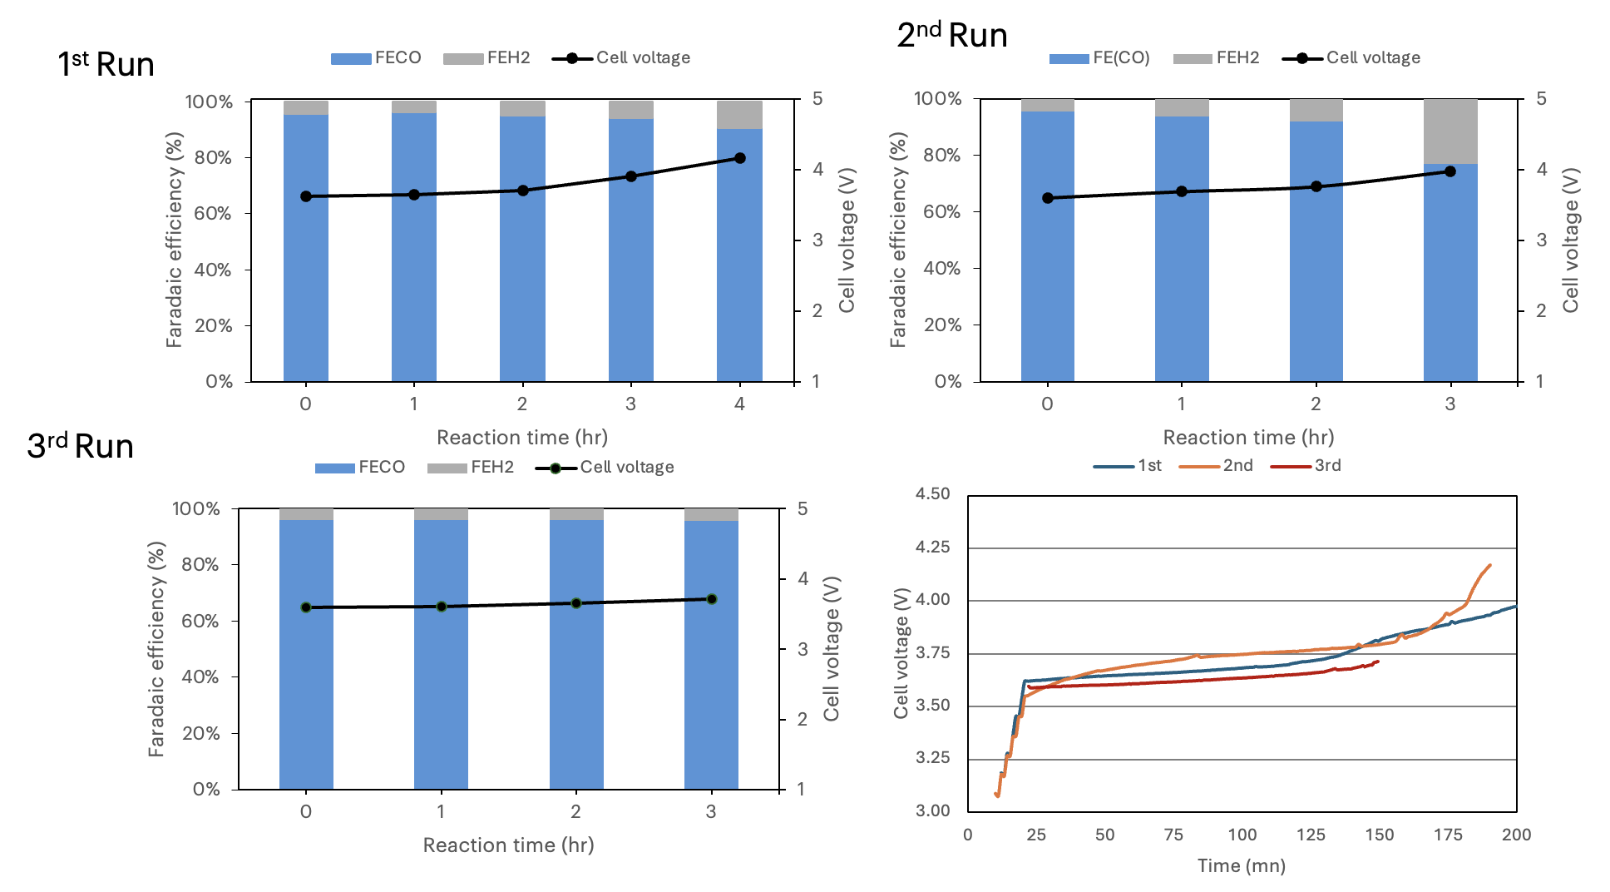
Figure 1. CO₂ electrolysis of 0.5Ni-SAC in a 100cm² MEA electrolyzer under 200ml/min pure CO₂, 100ml/min 0.25M KOH and Ni foam at 100mA/cm²

To test our hypothesis that a very diluted KOH concentration (0.25M) might lead to poor durability of the Ni foam, the KOH concentration was increased from 0.25M to 0.5M to ensure good ion conductivity of the Ni foam. Based on our observations, the cell instability remained the same (which might be attributed to water accumulation), except for a significant improvement in cell conductivity with lower cell potential compared to the previous operations.

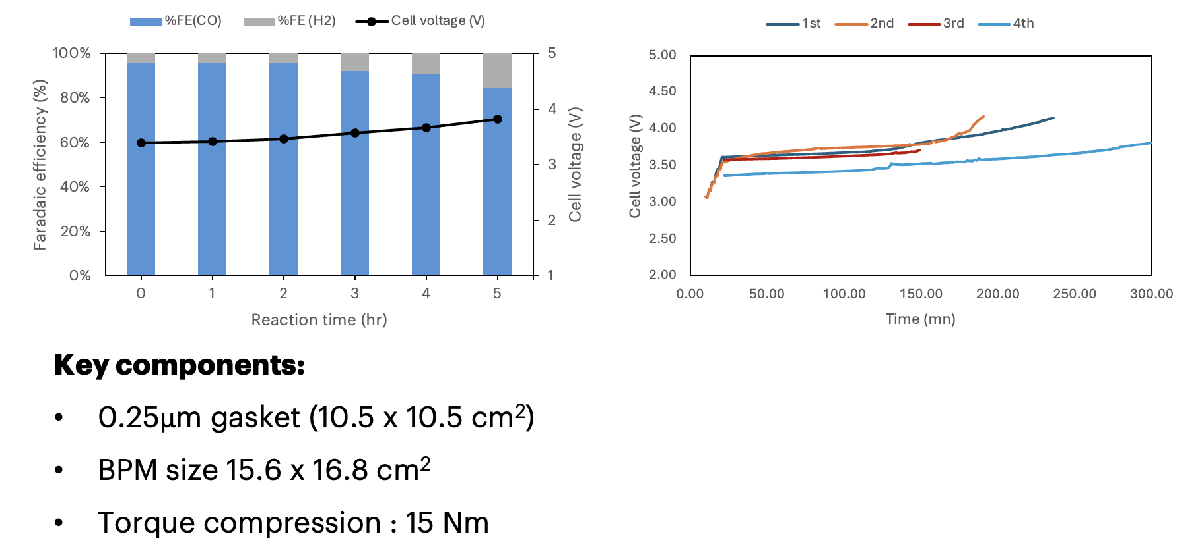
Figure 2. CO₂ electrolysis of 0.5Ni-SAC in a 100cm² MEA electrolyzer under 200ml/min pure CO₂, 100ml/min 0.5M KOH and Ni foam at 100mA/cm²

- Upcoming tasks
- Mitigation of water accumulation: 100cm² electrolyzer – CO₂ electrolysis of 0.5Ni-SAC under a pure CO₂ at 100mA/cm²
  - Increase gas flow rate (500-1000 ml/min)
  - Replace Ni foam with IrO₂-TiPt felt (1.0mg/cm²) to ensure the best performance at the anode side
  - Revisiting long-term CO₂ electrolysis of 5cm² MEA electrolyzer

